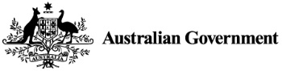
CourseSeeker.edu.au
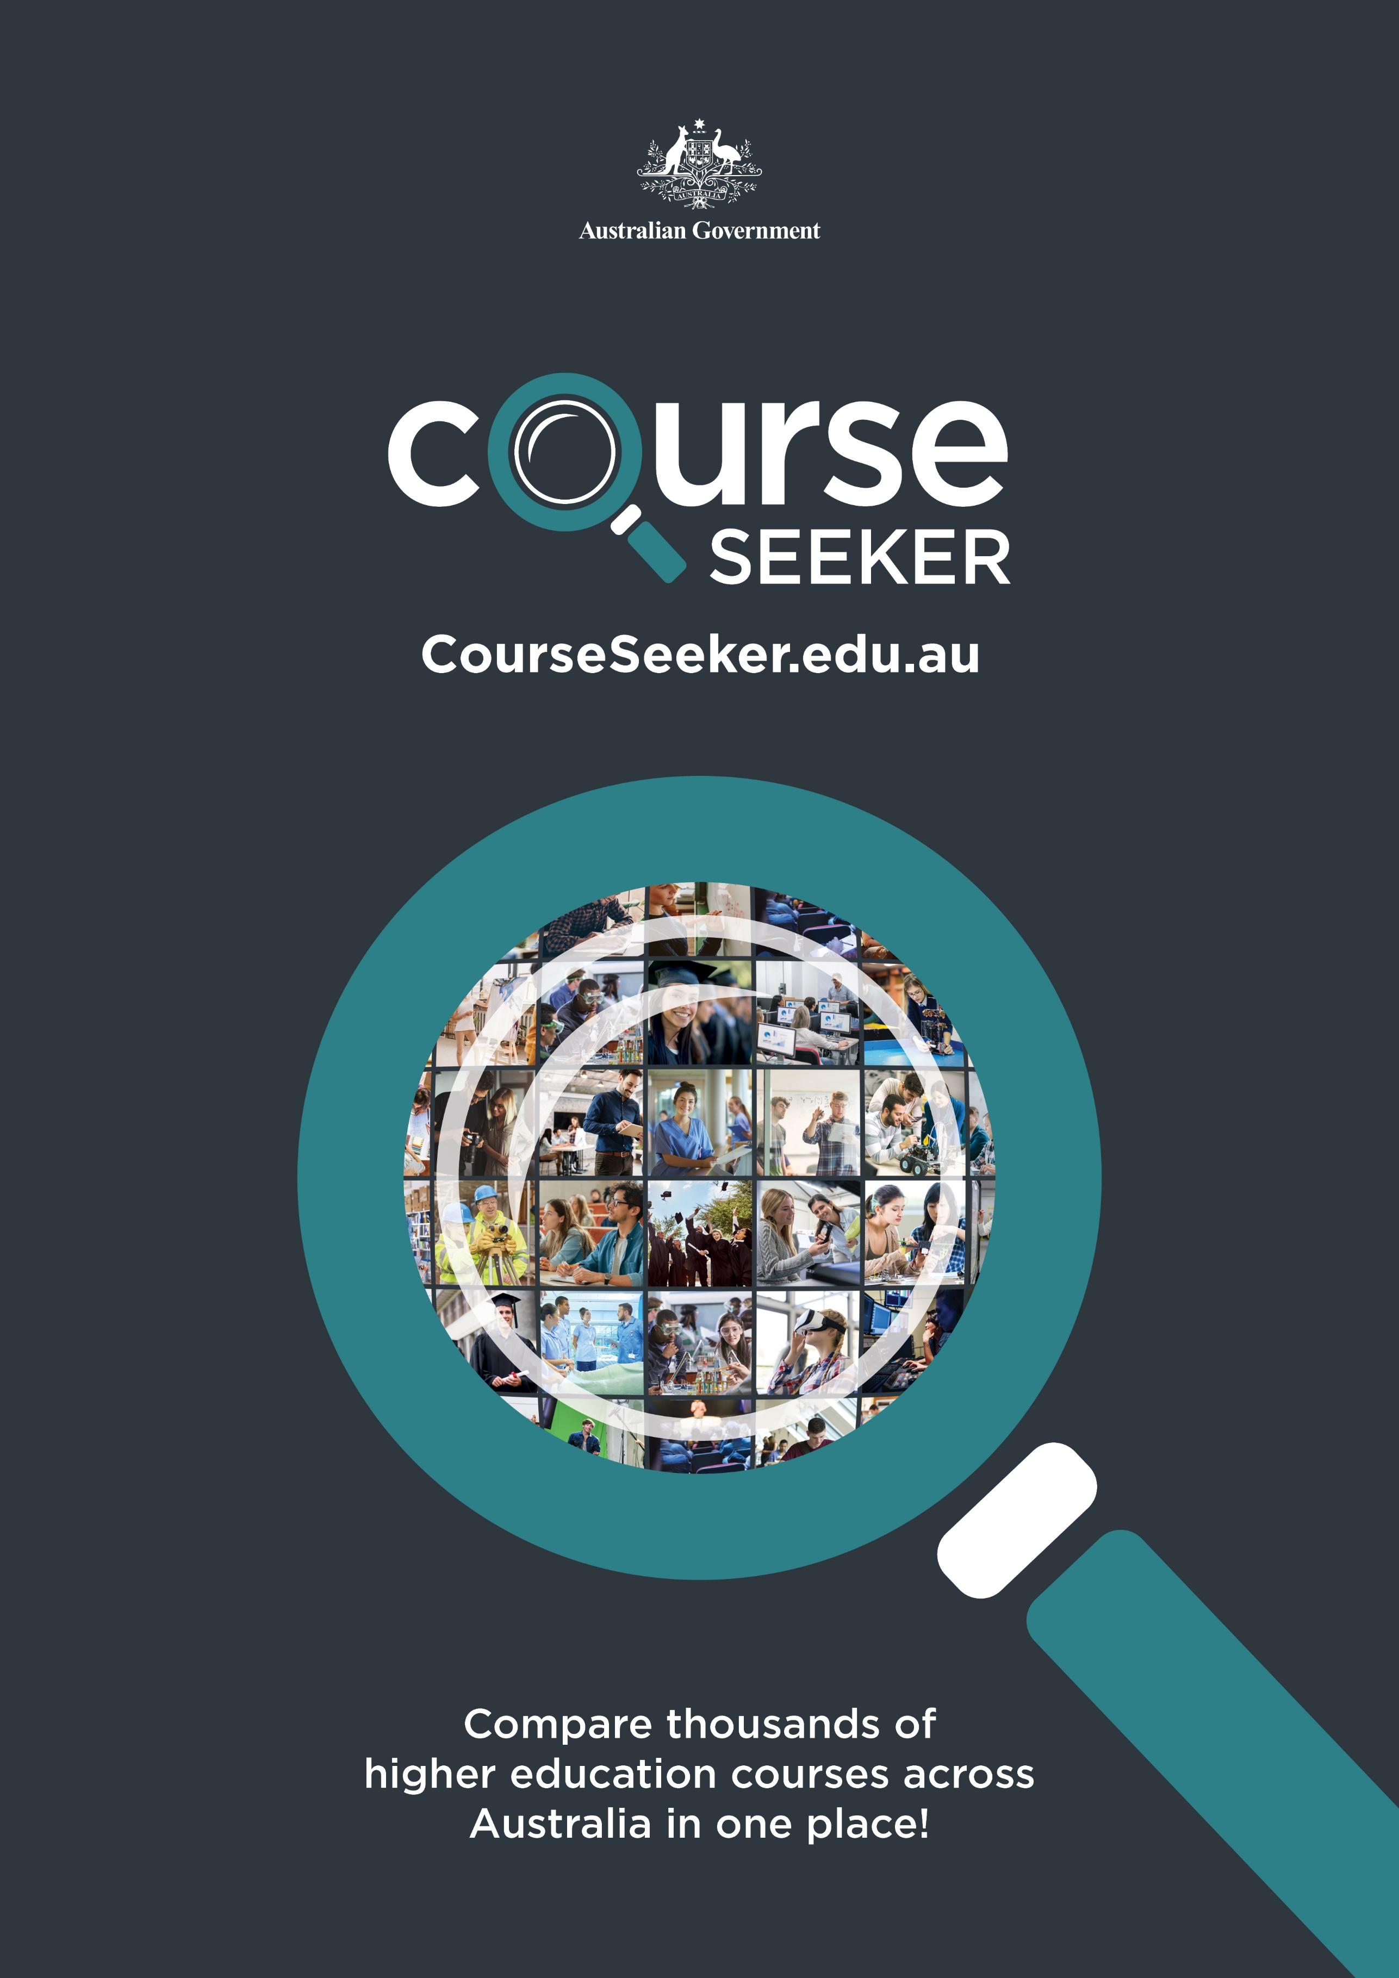
Compare thousands of higher education courses across Australia in one place!

