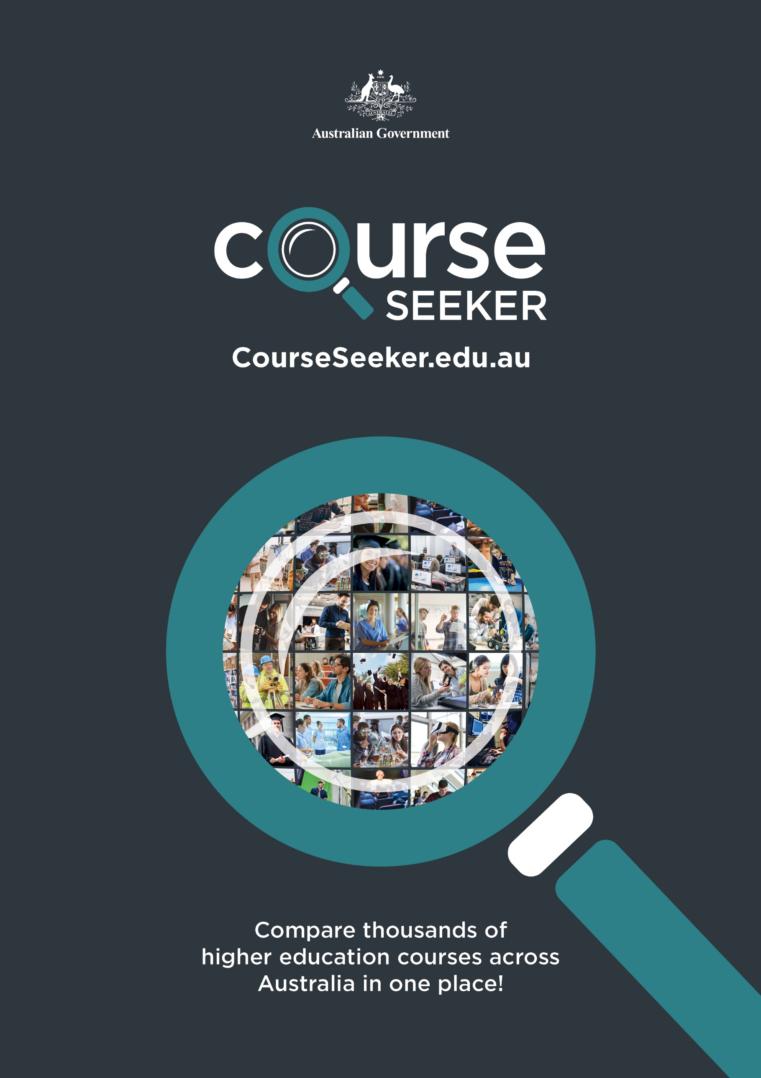
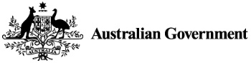
CourseSeeker.edu.au
Compare thousands of higher education courses across Australia in one place!

