Making decisions around uni?
Easy as 1,2,3
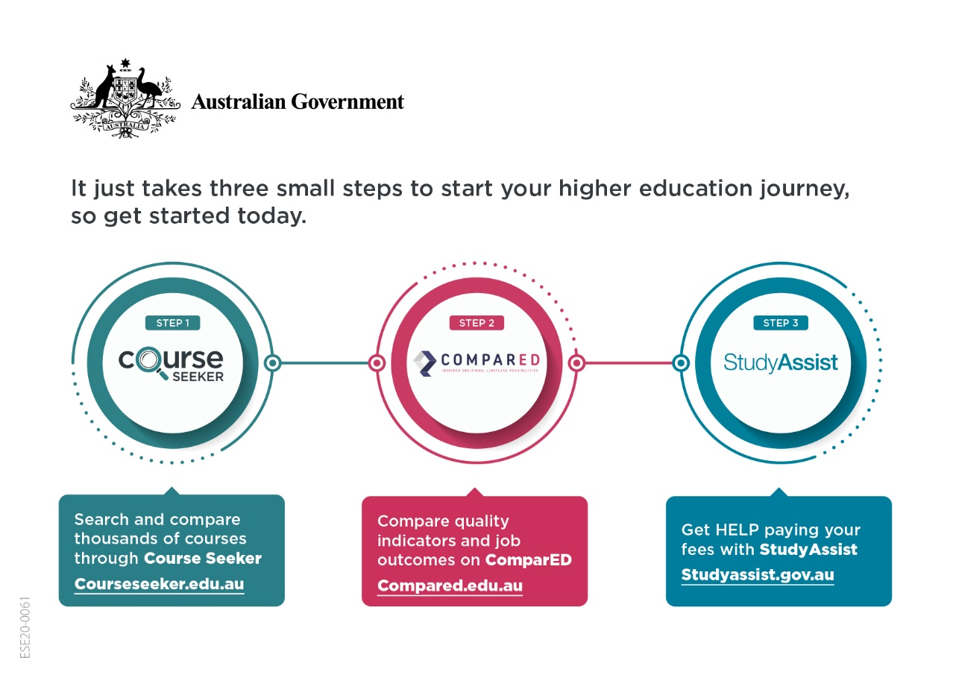

It just takes three small steps to start your higher education journey, so get started today.

Step 1 - Course Seeker
Search and compare thousands of courses through Course Seeker
CourseSeeker.edu.au

Step 2 - ComparED
Compare quality indicators and job outcomes on ComparED
ComparED.edu.au

Step 3 - Study Assist
Get HELP paying your fees with StudyAssist
Studyassist.gov.au

